# ***Java Project 5778***

Take & GO

Samuel benebri

**Id :838742**

Nathan Msika

**Id :333846244**

# First Application : Provider

This application is designed for the super organisation to add cars , model , branch. Administrators have to log in to acces the application. If there aren’t already registred they can sign up.

Internet is mandatory to use the application. All data are stocked online.

## Main Activity

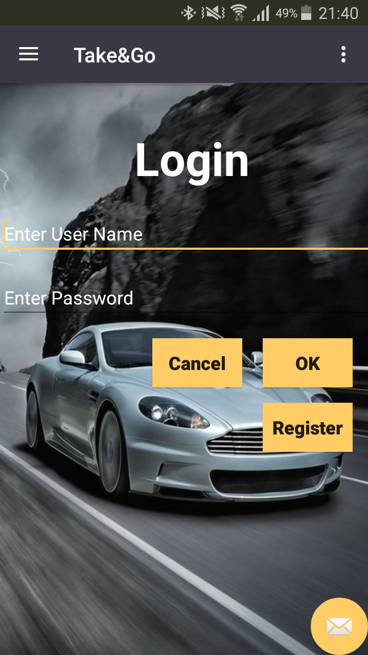

In the first activity, administrator have to log in by Name, and password. Valid by clik on SIGN IN. To test the application you can use Name: nath, Password: 321

Here we can Sign

## Navigtion drawer

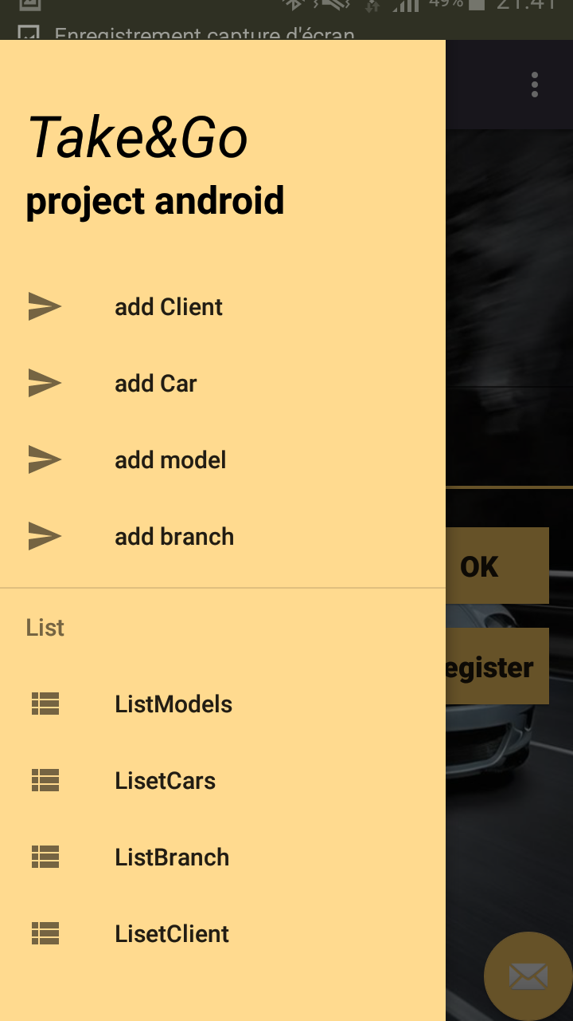

In case of bad login, dialog appear. Please check your login, or, if you aren’t already member please SIGN UP.

## Sign Up

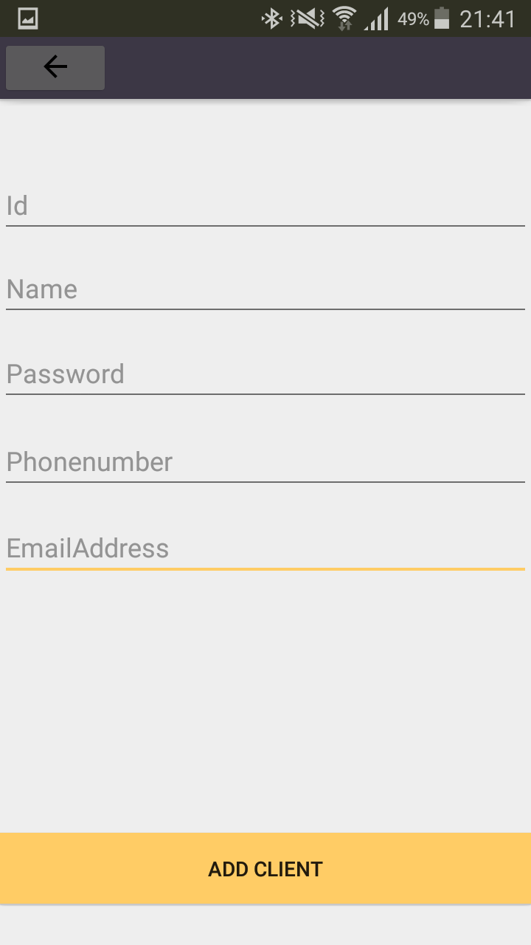

To become member, you have to put your name and choose a password. Valid by click on SIGN UP. Back to log in.

## Main Menu

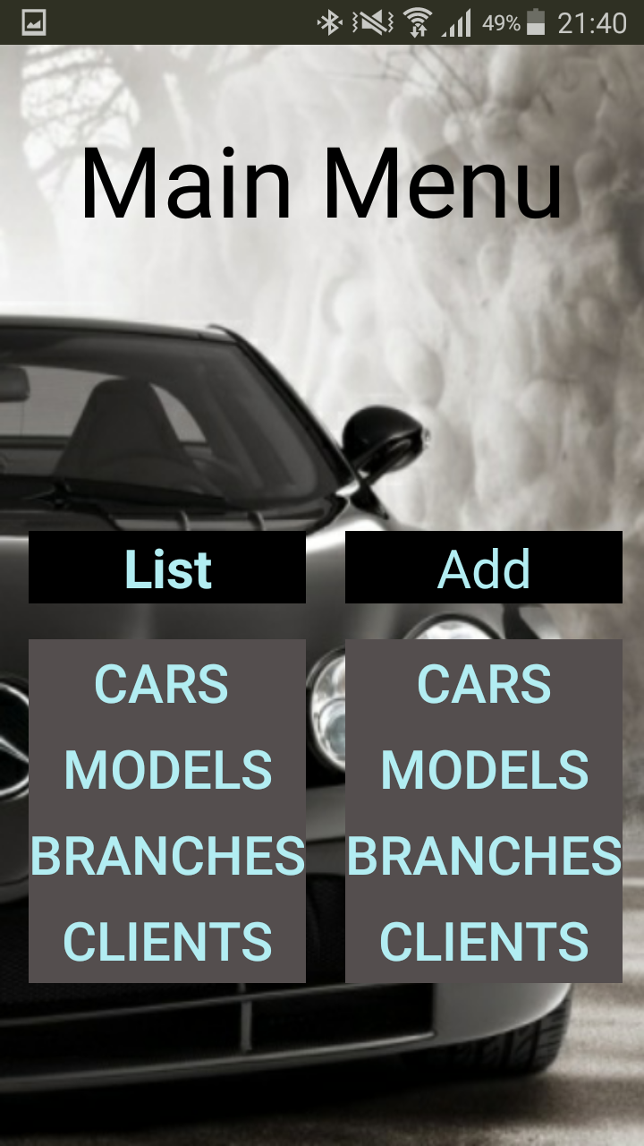

After succes log in, you are on the main menu. Choose add business to enter a new business in the database.

Choose add activity to enter a new activity.

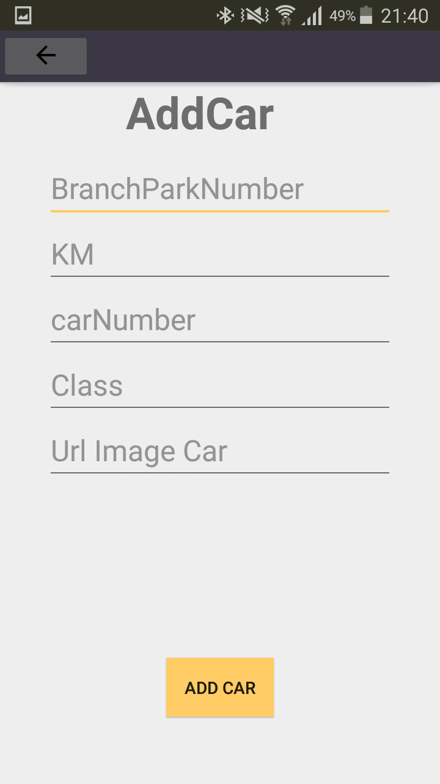

## Add Car

Please enter all details to complete registery of a new activity. You can select the business the activity is for.

Add details to be attractive. Valid by click on ADD ACTIVITY. Back to return to trhe main menu.

## Add Branch

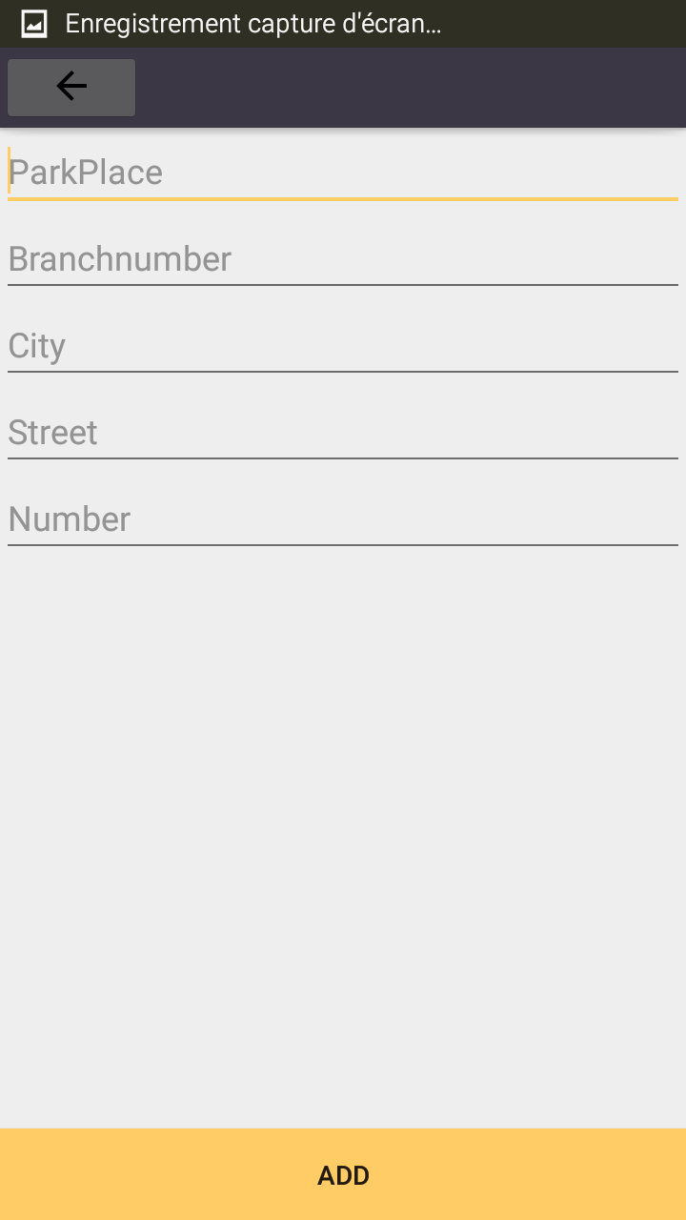

Please enter all details to complete registery of a new business.

Add website to be attractive. Valid by click on ADD BUSINESS. Back to return to trhe main menu.

## List Car

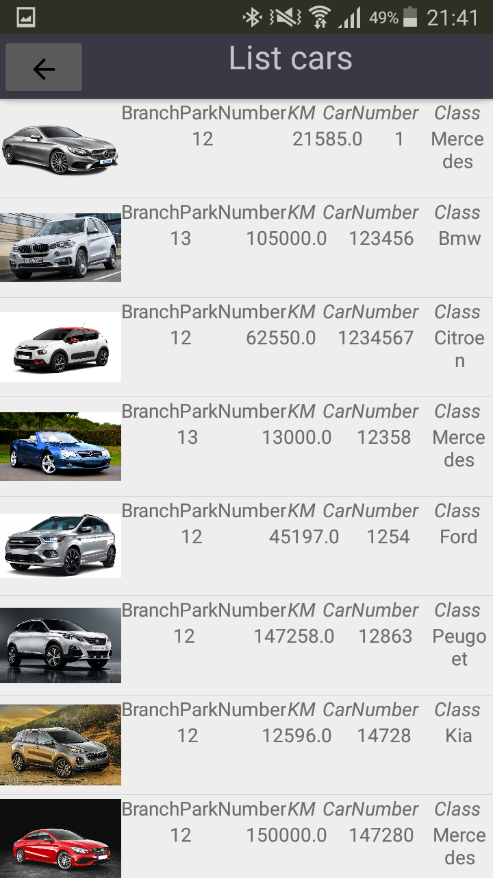

## List branch

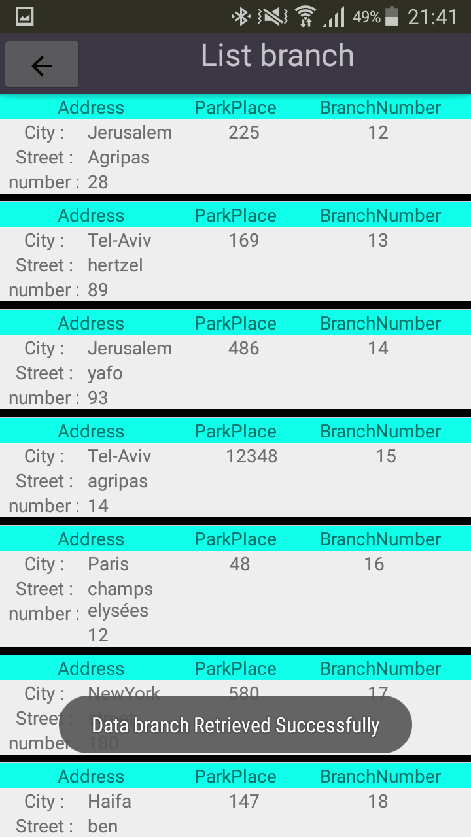In the menu you can choose to access to the list of activities or business. The third option is to exit the application.

## The Splash screen:



Here, you wait to download all list and add to static list in mysqldb-manger

## The login

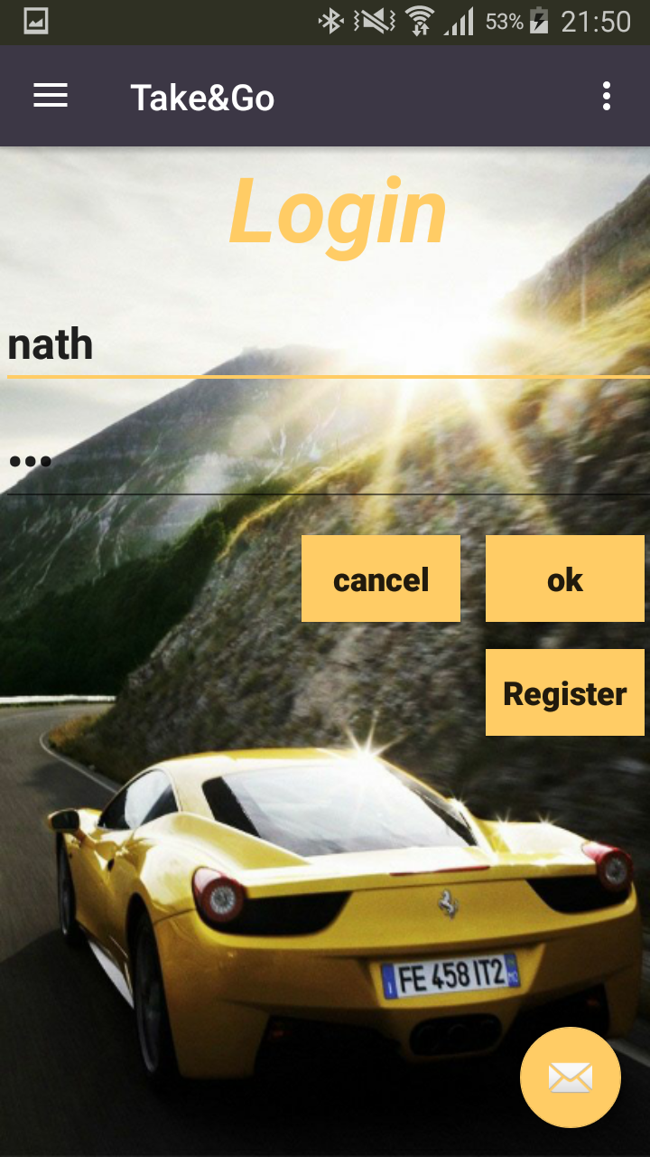

You may log in with your user name and password

If don’t have click to registry .

## Navigation Drawer

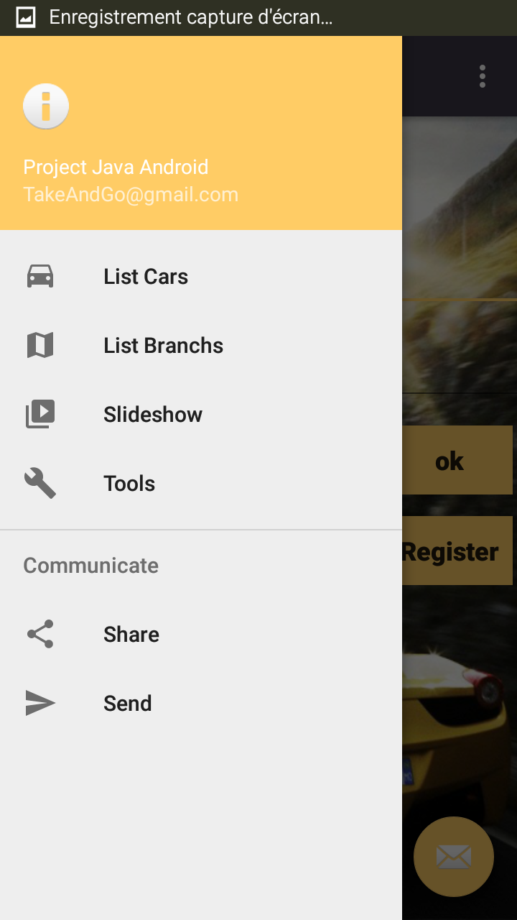

You can see all what do you want about the app before you sign in

## Menu Fragment

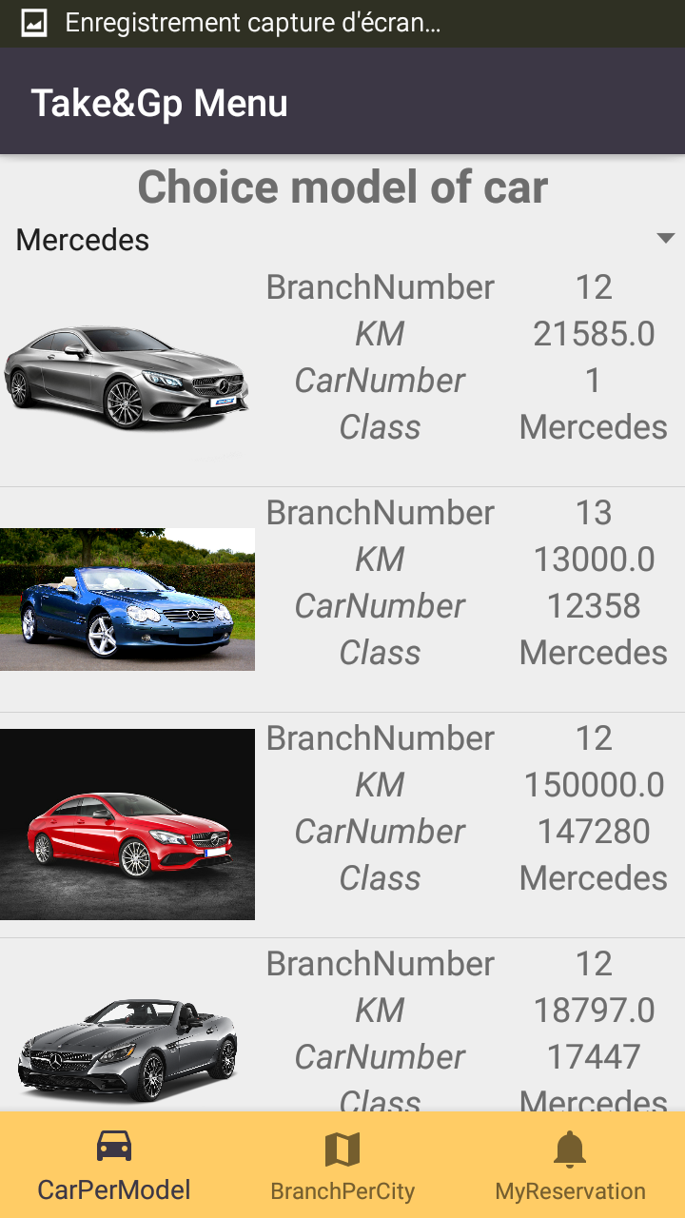

Her you have an menu about your app the model of car and branch and the statut of your rerservation

## Confirmation reservation of car

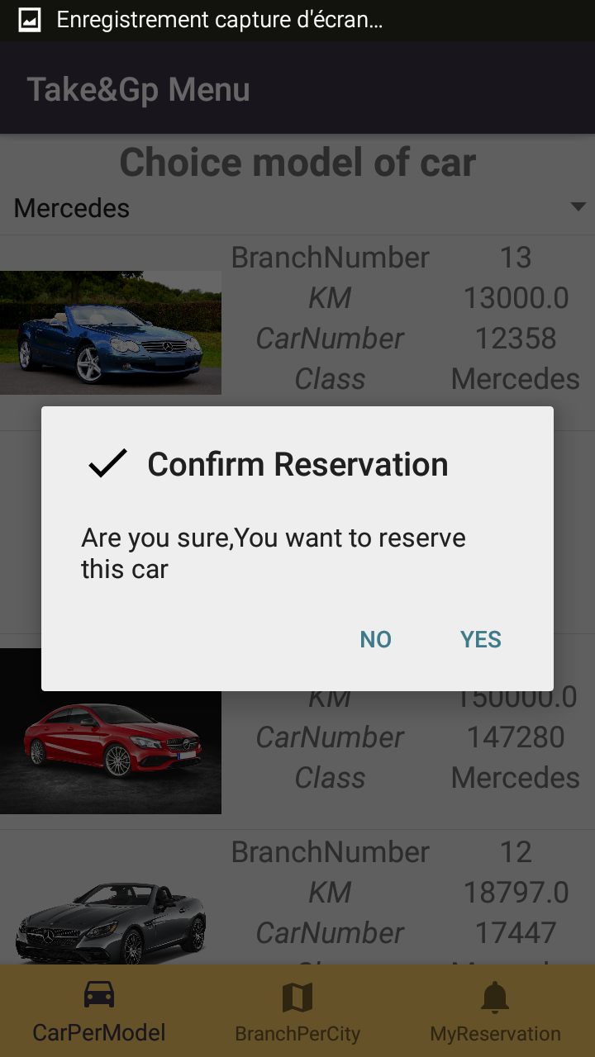

Click on to reserve and confirm your reservation

## Branch filter by city

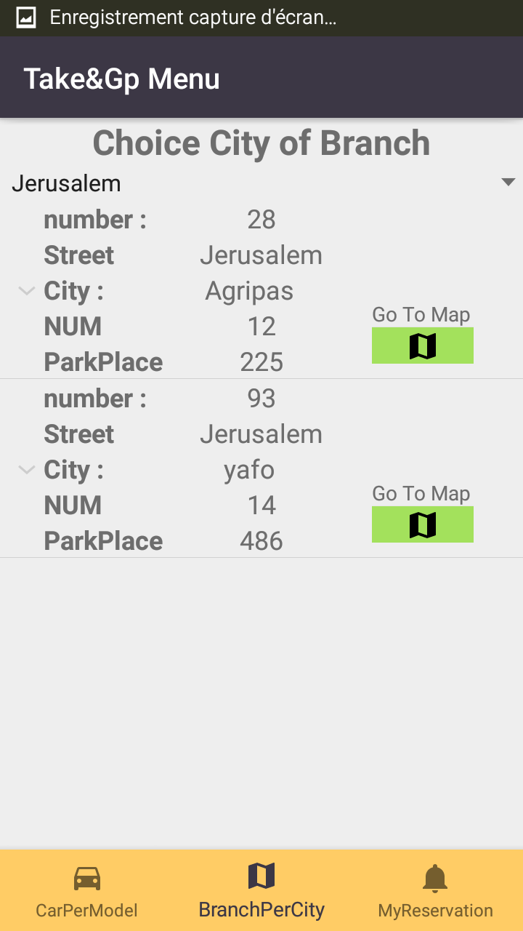

Click on city on you see all branch in this city

## Status Reservtion

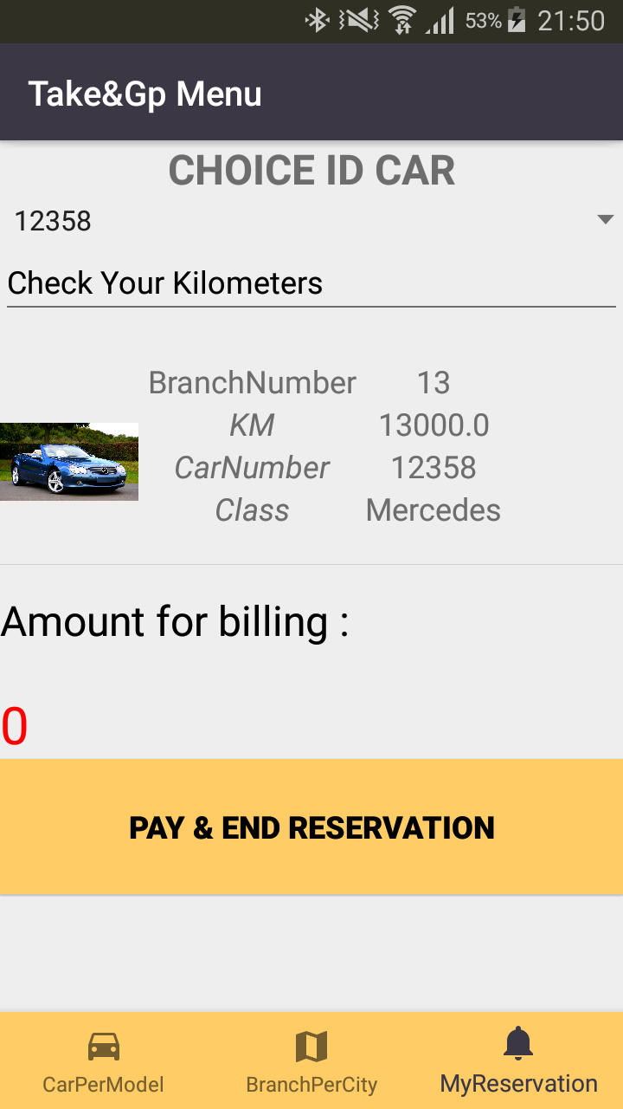

You can check your kilometer and end reservation , pay

